Ambari and Kafka Upgrade

Author: Jagadish Raj

Change History

The following Change History log contains a record of changes made to this document:

|  |  |  |  |  |
| --- | --- | --- | --- | --- |
| Published / Revised | Version # | Author (optional) | Reviewer | Section / Nature of Change |
|  |  |  |  |  |
|  |  |  |  |  |
|  |  |  |  |  |
|  |  |  |  |  |

Contents

Introduction 4

Audience 4

Components Upgraded 4

Upgrade Ambari 4

1. Preparing to Upgrade 4

2. Perform upgrade 4

Upgrade HDP 6

1. Pre-requisites: 6

2. Perform the upgrade 6

2.1 Register Target Version 6

2.2 Install Target Version 6

2.3 Perform the Upgrade 7

# Introduction

This document describes about upgrade of Ambari and Kafka

Ambari version is upgraded from 2.4.0.1 to 2.5.1

Ambari version is upgraded from 2.5.1. to 2.6.1

Kafka version is upgraded from 0.10.0.2.5 to 0.10.1.0

# Audience

COE – Integration Team

# Components Upgraded

* Ambari Server
* Ambari Agent
* Ambari Metrics
* Kafka

# Upgrade Ambari

## Preparing to Upgrade

1. Take backup of ambari server database.
2. Make a copy of Ambari Server configuration file found at */etc/ambari-server/conf/ambari.properties***.**
3. Stop Ambari-Metrics from Ambari GUI

## Perform upgrade

1. Stop the Ambari Server. On the host running Ambari Server:

*ambari-server stop*

1. Stop all Ambari Agents. On each host in your cluster running an Ambari Agent:

*ambari-agent stop*

1. Set latest ambari repo

On all hosts

Remove existing */etc/yum.repos.d/ambari.repo*

Set Proxy

*export http_proxy=http://web-proxy.corp.hpecorp.net:8080*

*export https_proxy=http://web-proxy.corp.hpecorp.net:8080*

Download latest repo for Ambari 2.5.1

wget -nv http://public-repo-1.hortonworks.com/ambari/centos7/2.x/updates/2.5.1.0/ambari.repo -O /etc/yum.repos.d/ambari.repo

Download latest repo for Ambari 2.6.1

wget -nv http://public-repo-1.hortonworks.com/ambari/centos6/2.x/updates/2.6.1.0/ambari.repo -O /etc/yum.repos.d/ambari.repo

1. Upgrade Ambari Server. On the host running Ambari Server:

*yum clean all*

*yum info ambari-server*

1. In the info output, visually validate that there is an available version containing "2.4"

*yum upgrade ambari-server*

1. Post install, only one version (2.4.*) of this jar should be present.

*ls -rlt /usr/lib/ambari-server/ambari-server\**

1. Upgrade Ambari Agent on each hosts:

*yum upgrade ambari-agent*

1. After the upgrade process completes, check each host to make sure the new files have been installed:

*rpm -qa | grep ambari-agent*

1. Upgrade Ambari Server database schema. On the host running Ambari Server:

*ambari-server upgrade*

1. Start the Ambari Server. On the host running Ambari Server:

*ambari-server start*

1. Start all Ambari Agents. On each host in your cluster running an Ambari Agent:

*ambari-agent start*

1. If you have configured Ambari to authenticate against an external LDAP or Active Directory, you must re-run

*ambari-server setup-ldap*

1. Clear browsing data on browser and reload ambari UI url
2. Upgrade Ambari-Metrics components on all hosts where it was installed

Stop all ambari-metrics components

*yum clean all*

*yum upgrade ambari-metrics-monitor ambari-metrics-hadoop-sink*

Upgrade Ambari-metrics collecter

*yum upgrade ambari-metrics-collector*

1. Restart all components that require restart from ambari UI
2. Add grafana component for ambari metrics (if old version on ambari is 2.2.1 or earlier)

Add the METRICS_GRAFANA component to Ambari:

*curl –k -u admin:admin -H "X-Requested-By:ambari" -i -X POST http://ambari.server:8080/api/v1/clusters/cluster.name/services/AMBARI_METRICS/components/METRICS_GRAFANA*

Example

*curl -k -u admin:admin -H "X-Requested-By:ambari" -i -X POST https://hc4t01825.itcs.hpecorp.net:8443/api/v1/clusters/kafka_csav2_sbx01/services/AMBARI_METRICS/components/METRICS_GRAFANA*

Add METRICS_GRAFANA to a host in the cluster

*curl -u admin:admin -H "X-Requested-By:ambari" -i -X POST -d '{"host_components":[{"HostRoles":{"component_name":"METRICS_GRAFANA"}}]}' http://ambari.server:8080/api/v1/clusters/cluster.name/hosts?Hosts/host_name=host.name*

Example

*curl -k -u admin:admin -H "X-Requested-By:ambari" -i -X POST -d '{"host_components":[{"HostRoles":{"component_name":"METRICS_GRAFANA"}}]}'* [*https://hc4t01825.itcs.hpecorp.net:8443/api/v1/clusters/kafka_csav2_sbx01/hosts?Hosts/host_name=hc4t01825.itcs.hpecorp.net*](https://hc4t01825.itcs.hpecorp.net:8443/api/v1/clusters/kafka_csav2_sbx01/hosts?Hosts/host_name=hc4t01825.itcs.hpecorp.net)

From Ambari Web, browse to Services > Ambari Metrics and you will see Grafana is in the Install Pending… state. You need to complete the configuration of Grafana before installing and starting.

To complete the configuration, click on Services > Ambari Metrics > Configs and you will need to enter the default Grafana Admin Password in the General section. Click Save.

Browse to Hosts > host.name (i.e. the host.name used in the API call where you added Grafana). You will see the Grafana component is in an Install Pending… state. Use the Install Pending… action button and select Re-install.

# Upgrade HDP

## Pre-requisites:

All services should be running in Ambari. None of them should be in maintenance modes

Below property should be removed from Kafka config

*export JMX_PORT=7000*

## Perform the upgrade

### Register Target Version

1. Log in to Ambari.
2. Browse to Admin > Stack and Versions.
3. Click on the Versions tab. You will see the version currently running, marked as "Current"
4. Click Manage Versions
5. Proceed to register a new version by clicking + Register Version.
6. Select the software version and method of delivery for your cluster.

**Choose HDP Stack**. The available HDP versions are shown in TABs. When you select a TAB, Ambari attempts to discover what specific version of that HDP Stack is available. That list is shown in a DROPDOWN. For that specific version, the available Services are displayed, with their Versions shown in the TABLE.

**Choose HDP Version**. If Ambari has access to the Internet, the specific Versions will be listed as options in the DROPDOWN. If you have a Version Definition File for a version that is not listed, you can click Add Version… and upload the VDF file. In addition, a Default Version Definition is also included in the list if you do not have Internet access or are not sure which specific version to install. If you choose the Default Version Definition, you must enter a "two-digit Version Number" in the Name input field.

**Choose Repository Delivery Method**. Using a Public Repository requires Internet connectivity. Using a Local Repository requires you have configured the software in a repository available in your network. To use the public software repositories, see the list of available HDP Repositories for each OS. Or, if you are using a local repository, enter the Base URLs for the local repository you have created.

1. Click Save.
2. Click Go To Dashboard, and browse back to Admin > Stack and Versions > Versions.
3. You will see the version currently running, marked "Current", and the version you just registered HDP-2.6.4.0 which is showing an Install button.
4. Proceed to Install Target Version.

### Install Target Version

1. Log in to Ambari.
2. Browse to Admin > Stack and Versions.
3. Click on the Versions tab.
4. Click Install and click OK to confirm.
5. The Install version operation will start. This will install the target version on all hosts in the cluster. You can monitor the progress of the install by clicking the “Installing” link.
6. Once the install is complete, the Install button will be replaced with the option to Upgrade.
7. Proceed to Perform the Upgrade.

### Perform the Upgrade

1. Log in to Ambari.
2. Browse to Admin > Stack and Versions.
3. Click on the Versions tab. The registered and installed target HDP version should be visible.
4. Click Perform Upgrade on the target version.
5. Based on your current HDP version and the target HDP version, Ambari will perform a set of prerequisite checks to determine if you can perform a Rolling Upgrade or an Express Upgrade. A dialog will be presented with the options available.
6. Also disable the Auto start from Ambari UI->Admin🡪Service🡪AutoStart🡪Disbale it-🡪Save it.

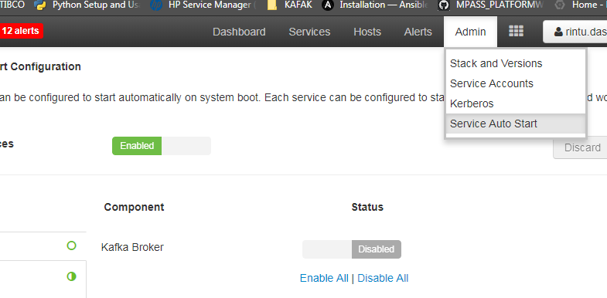

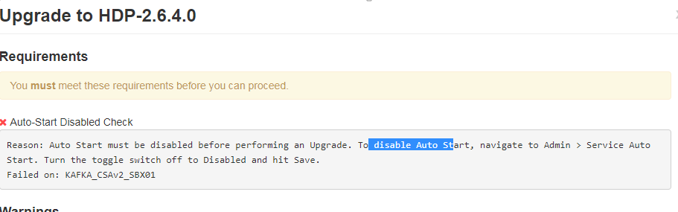

1. Select your upgrade method: Rolling Upgrade or Express Upgrade. There are also advanced options available.
2. Once the upgrade is complete, you have an option to finalize the upgrade. Once finalized, you cannot downgrade back to the previous version.
3. After upgrade add below to KAFKA Config

*export JMX_PORT=7000*

1. On all Kafka servers, perform this step.

Copy the library jar files for kafka (mongo-java-driver-2.12.2.jar, hpfs-kafka-metrics-1.1.jar, SSLCNPrincipal-0.0.1-SNAPSHOT.jar)

From – /usr/hdp/2.5.3.0-37/kafka/libs

To- /usr/hdp/2.6.4.0-91/kafka/libs/

1. Restart Kafka